Website Hacking

Revision

Day 4
Topic – Install the Cyberfox browser
Cyberfox is a Mozilla-based Internet browser designed to take advantage of 64-bit architecture but a 32-bit version is also available. The application provides a higher memory performance when navigating your favourite pages.
1.Open and search cyberfox
2. Download the cyberfox browser
Here the link - https://sourceforge.net/projects/cyberfox/#
3. Opened it install and finish this.
Here the browser –
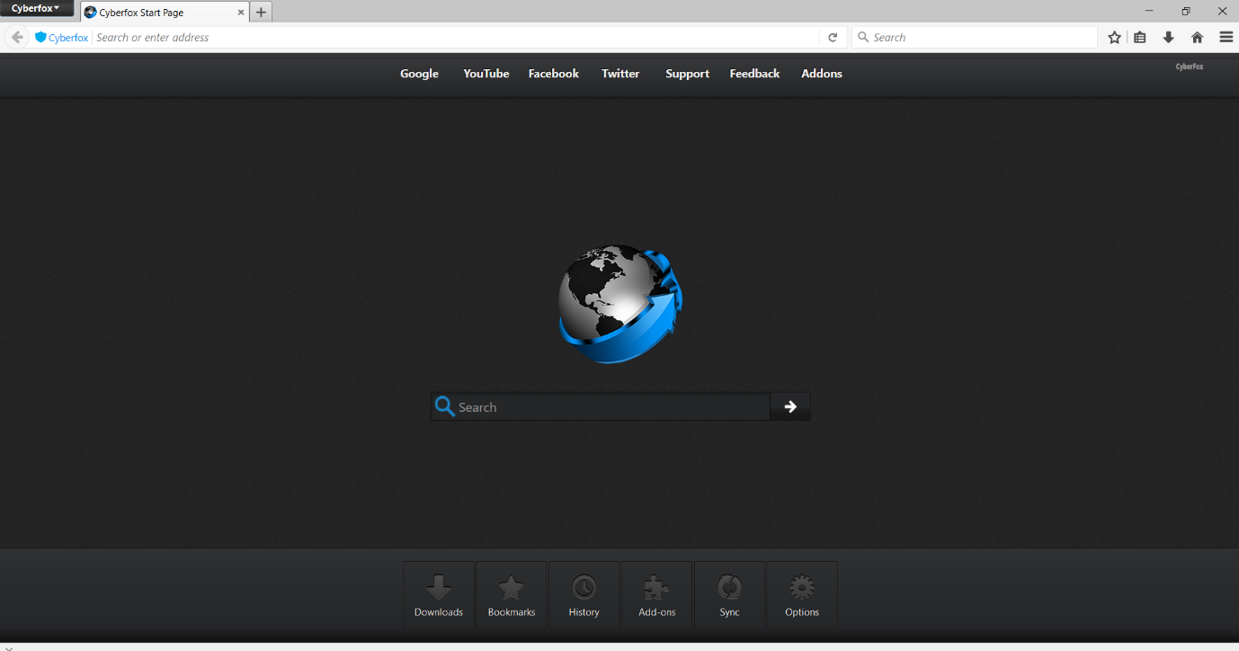

Open -> click “main-menu” -> click “add-ones” -> then add that you want.
